Arduino Based Dual Axis Solar Panel

Tafsir Ahamed  
Department of Computer Science and Engineering  
Daffodil International UniversityDhaka, Bangladesh  
E-mail: [tafsir15-9143@diu.edu.bd](mailto:tafsir15-9143@diu.edu.bd)

Mahmudul Hasan  
Department of Computer Science and Engineering  
Daffodil International UniversityDhaka, Bangladesh  
E-mail: [mahmudul15-8624@diu.edu.bd](mailto:mahmudul15-8624@diu.edu.bd)

*Abstract*— *Sun powered vitality is quickly progressing as a significant methods for sustainable power source asset. Sun is a bountiful wellspring of vitality and this sun powered vitality can be tackled effectively utilizing sunlight based photovoltaic cells and photovoltaic impact to change over sun oriented vitality into electrical vitality. Solar Panels basically direct sun powered boards or modules toward the sun. These gadgets change their direction for the duration of the day to follow the sun's way to amplify vitality catch. The utilization of sunlight based boards can build power creation by around a third, and some case by as much as 40% in certain areas, contrasted and modules at a fixed edge. In any sun based application, the transformation proficiency improves when the modules are persistently acclimated to the ideal edge as the sun crosses the sky. This paper presents the simulation of an Arduino based dual axis solar panel.*

Keywords— Arduino UNO, Solar Panel, Servo Motor.

# **Introduction**

Sun is a plentiful wellspring of vitality and this sun powered vitality can be tackles effectively utilizing sun oriented photovoltaic cells and photovoltaic impact to change over vitality into electrical vitality. Yet, the transformation proficiency of a typical PV cell is low. The main reason for this is the output of PV cell depends on the light intensity and with the position of sun in the sky which changes continuously from time to time, a solar panel’s efficiency would be significantly less at certain time day and year. The solar PV cells are maximum productive when they are perpendicular to the sun and less productive in other case. So solar panels are required to maximize the energy generation and improve the efficiency.

The sun based tracker likewise gave worthwhile answer for underdeveloped nations to coordinate it into their close planetary system with a nearly ease through programming based arrangement. The investigation uncovered that utilization of stepper engine empowers exact following of sun and LDR resistors used to decide the sun powered light force [1]. Specialists presumed that inserting the global positioning framework with sun oriented board can reaction exact and relevant to satisfy the force needs at various operational conditions.

. A sun powered global positioning framework planned with microcontroller and LDR's that effectively track the sun and change its position appropriately to expand the vitality yield. The LDR fused on sun oriented board assists with distinguishing daylight which thusly moves the board in like manner [2] .The sunlight based tracker portrayed a more improved approach to boost the force utilization by sun oriented board from sun by simply turning the sun powered board as indicated by sun's position. By looking at the outcomes it was found that immediate light emission helps in creating vitality than it is delivered when sun oriented board is kept fixed. The contemplated have demonstrated that effectiveness of sun powered boards can be expanded generally if the sun oriented boards persistently pivot toward sun. Microcontroller and a course of action of LDR sensors can be utilized to follow the sun [3]. Be that as it may, the framework was less productive as a result of the low affectability and unsettling influence of light ward resistors. The component of sun powered following was actualized by the utilization of picture handling programming which consolidates the impact of sensors and prepared picture of sun and controls the sun oriented board as needs be.

There is another mechanical structure for solar panels which consists of two stepper engines with the expectation of complimentary turn on X and Y hub [4]. The turn is constrained by a pre-modified 2K microcontroller gadget which gives straightforward programming procedure through C language. The structured calculation depended on the estimation of power of sunlight based radiation which was caught by a bright touchy gadget known as Pyranometer. The framework had been tried and the outcomes show exceptionally huge effect on the mechanical structure, controlling calculation and furthermore the expense of the turn of events.

# **METHODOLOGY**

The fundamental part is Arduino uno; single-board microcontroller. It has an open source physical registering stage and an improvement situation for composing programming for the board and is reasonable. The other primary segments are Light Dependent Resistors (LDRs); servo-engines; sun oriented board. The sun powered global positioning framework is finished by Light Dependent Resistor (LDR). Four LDR are associated with Arduino simple pin A2 to A5 that goes about as the contribution for the framework. The simple estimation of LDR is changed over into computerized (Pulse Width Modulation) utilizing the implicit Analog-to­ Digital Converter. The estimations of PWM beat are applied to move the servos. The greatest light power caught by the one of the LDRs information will be chosen and the servo engine will move the sun oriented board to the situation of the LDR that was set-up in the programming. There are two purposes of engine turn; 180 and 45 degrees. The places of LDR are isolated into four positions; which are upper left; upper right; base left; base right. The four positions permit the most elevated force of daylight to be can be identified. The microcontroller gets a simple contribution from the Light Dependent Resistor (LDR) which is then changed over into computerized signal by Analog-to-Digital converter. The development of the sun oriented board is dictated by the yield given to the servo engine.

# **Hardware Implementation**

Figure 1 depicts the layout of the hardware and their interconnections.

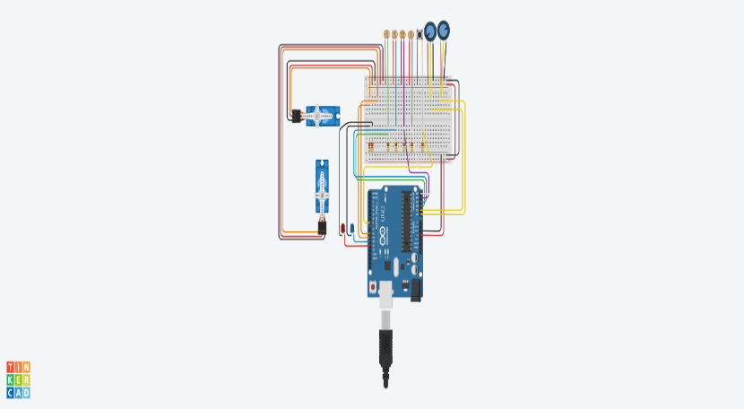

Figure 1: Circuit Diagram.

1. **SOFTWARE IMPLEMENTATION**

The product part comprises of a programming language that is developed utilizing C++ programming. The codes are focused to Arduino UNO to be gathered and transferred. The equipment and programming is actualized and incorporated to structure and build up the total double hub Solar Panel.List of main components used for the design and implementation are given in Table 1.

|  |  |  |
| --- | --- | --- |
| SL No. | Components | Qty |
| 1 | Arduino Uno R3 | 1 |
| 2 | Micro Servo | 2 |
| 3 | LDR(250 kilo ohm) | 2 |
| 4 | Pushbutton | 1 |
| 5 | Photoresistor | 4 |
| 6 | Resistors | 7 |
| 7 | Wire |  |

# **Hardware Description**

Below are short definitions for components that using in system prototype.

1. **Light Dependent Resistor (LDR) Sensors**

LDRs are also named as photo conductors or photo resistors and the photoconductivity is the principal of their working. LDR resistance is increased with decrease light intensity and vice versa. Solar energies catch by purpose sensing which are done by using LDRs before providing the input analog to Arduino.

1. **Servo Motor**

Servo mechanism is the principle work of dc motor which has 3 wires and maximum angle of 180° can be rotated. There are two servo motors using for both horizontal and vertical directions because the system is working in dual axis. Arduino provides output of PWM to these servo motors for operation.

1. **Solar Panel**

Solar energy is a group of photovoltaic cells that produce electrical energy from sun light energy and convert the received light energy from sun into electrical energy. Solar panel extracts high-energy emitted from the sun. They are widely applications of solar panel in industrial area, domestic and street lights.

1. **Arduino**

Arduino type Uno R3 is a microcontroller that using in this work for motor position control. Arduino has 14 input/output digital ports that provide signals of PWM to servo motor by 6 of them and 6 input ports as analogue, also contains oscillator crystal of 16 MHz and cable USB for push through program. The Arduino advantages are independent platform, construction robust and low price. Table 1 shows the components description of the system prototype depending on their functions.

# **Conclusion**

The point of this paper is to provide a simulated framework of a dual axis solar panel which can detect sun light on the board and move toward it to gain the maximum solar. From this investigation the fundamental ends are:

• Proposed simulated framework is ease and minimized when contrasted with the other solar panel frameworks being used for same application.

• The programming of this solar panel is extremely simple and easy to adjust on the ground because it is Arduino based and no outside things are required.

• The simulated framework is anything but difficult to utilize and gives better effectiveness.

• In the simulated framework there will be system developed to recover continuous information on the android gadget.

**REFERENCES**

[1] Khyati vyas, Dr. Sudhir Jain, Dr. Sunil Joshi, “A Review on an Automatic Solar tracking System”, International Journal of Computer Applications, 2014.

[2] Priyanjan Sharma, Nitesh Malhotra, “Solar Tracking System Using Microcontroller”, Proceedings of 1st International Conference on Non- Conventional Energy, pp. 77-79, January 16-17, 2014.

[3] H. A. Sohag, M. Hasan, M. Khatun and M. Ahmad, "An accurate and efficient solar tracking system using image processing and LDR sensor," 2015 2nd International Conference on Electrical Information and Communication Technologies (EICT), Khulna, 2015, pp. 522-527, doi: 10.1109/EICT.2015.7392008.

[4] M. A. Abas, M. H. F. S., S. A. Kadir and A. K. Azim, "Improved Structure of Solar Tracker with Microcontroller Based Control," 2010 Second International Conference on Advances in Computing, Control, and Telecommunication Technologies, Jakarta, 2010, pp. 55-59, doi: 10.1109/ACT.2010.28.